**Operations Research Project Report**



**Topic: Linear Programming Models**

**For: Hakeem-ur-Rehman, PhD**

**Name:** Muhammad Hassan Raza

**Roll Number:** 20L-1361

**Section:** SE – 5A

Table Of Contents

Problem 1 4

**Solution:** 4

**Interpretation of Results:** 4

Problem 2 5

**Solution:** 5

**Interpretation of Results:** 5

Problem 3 6

**Solution:** 6

**Interpretation of Results:** 6

Problem 4 7

**Solution:** 7

**Interpretation of Results:** 7

Problem 5 8

**Solution:** 8

**Interpretation of Results:** 8

Problem 6 9

**Solution:** 9

**Interpretation of Results:** 9

Problem 7 10

**Solution:** 10

**Interpretation of Results:** 10

Problem 8 11

**Solution:** 11

**Interpretation of Results:** 11

Problem 9 12

**Solution:** 12

**Interpretation of Results:** 12

Problem 10 13

**Solution:** 13

**Interpretation of Results:** 13

Problem 11 14

**Solution:** 14

**Interpretation of Results:** 14

Problem 12 15

**Solution:** 15

**Interpretation of Results:** 15

Problem 13 16

**Solution:** 16

**Interpretation of Results:** 16

Problem 14 17

**Solution:** 17

**Interpretation of Results:** 17

Problem 15 18

**Solution:** 18

**Interpretation of Results:** 19

# 

# **Problem 1**

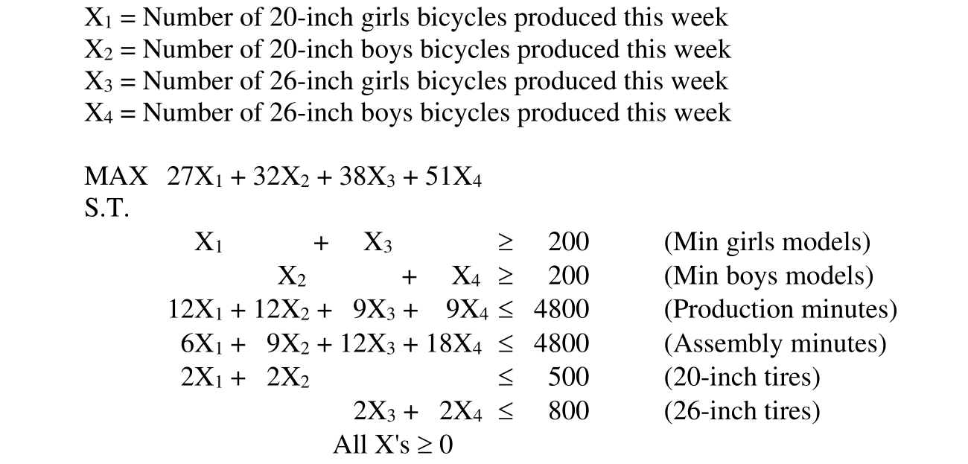

## **Solution:**

x1 = 150.0 Reduced Cost = -0.0

x2 = 100.0 Reduced Cost = -0.0

x3 = 100.0 Reduced Cost = -0.0

x4 = 100.0 Reduced Cost = -0.0

Optimal Value: 16150.0

## **Interpretation of Results:**

The optimal Value of this problem is 16150.0. Furthermore, the cost reduced per unit of decision variable is 0.0. This means that the cost won’t be reduced per unit decrease the value of the decision variable.

# **Problem 2**

## **Solution:**

## x1 = 266.667 Reduced Cost = 0.0

## x2 = 448.718 Reduced Cost = 0.0

## x3 = 0.0 Reduced Cost = -11.538

## x4 = 0.0 Reduced Cost = -8.269

## x5 = 133.333 Reduced Cost = 0.0

## Optimal Value: 87051.2821

## **Interpretation of Results:**

The optimal Value of this problem is 87051.2821. Furthermore, the cost reduced per unit of some decision variables is non-zero. This means that the cost will be reduced per unit decrease the value of the decision variable.

# **Problem 3**

## **Solution:**

x1 = 22.936 Reduced Cost = -0.0

x2 = 0.0 Reduced Cost = -44.954

x3 = 22.936 Reduced Cost = -0.0

x4 = 45.872 Reduced Cost = -0.0

x5 = 91.743 Reduced Cost = -0.0

Optimal Value: 54128.4408

## **Interpretation of Results:**

The optimal Value of this problem is 54128.4408. Furthermore, the cost reduced per unit of some decision variables is non-zero. This means that the cost will be reduced per unit decrease the value of the decision variable.

# **Problem 4**

## 

## **Solution:**

x1 = 7500.0 Reduced Cost = 0.0

x2 = 0.0 Reduced Cost = -0.03

x3 = 2500.0 Reduced Cost = 0.0

x4 = 30000.0 Reduced Cost = 0.0

x5 = 0.0 Reduced Cost = -0.125

x6 = 10000.0 Reduced Cost = 0.0

x7 = 10000.0 Reduced Cost = 0.0

Optimal Value: 5250.0

## **Interpretation of Results:**

The optimal Value of this problem is 5250.0. Furthermore, the cost reduced per unit of some decision variables is non-zero. This means that the cost will be reduced per unit decrease the value of the decision variable.

# **Problem 5**

## **Solution:**

x1 = 240.0 Reduced Cost = 0.0

x2 = 312.0 Reduced Cost = 0.0

x3 = 120.0 Reduced Cost = -1.35

Optimal Value: 5568.0

## **Interpretation of Results:**

The optimal Value of this problem is 5568.0. Furthermore, the cost reduced per unit of some decision variables is non-zero. This means that the cost will be reduced per unit decrease the value of the decision variable.

# 

# **Problem 6**

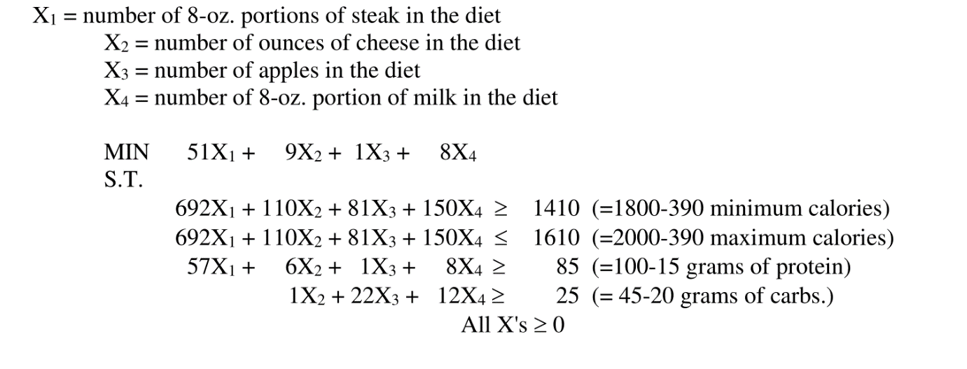

## **Solution:**

x1 = 1.395 Reduced Cost = 0.0

x2 = 0.0 Reduced Cost = 3.575

x3 = 5.49 Reduced Cost = 0.0

x4 = 0.0 Reduced Cost = 0.761

Optimal Value: 76.6306

## **Interpretation of Results:**

The optimal Value of this problem is 76.6306. Furthermore, the cost reduced per unit of some decision variables is non-zero. This means that the cost will be reduced per unit decrease the value of the decision variable.

# **Problem 7**

## **Solution:**

x1 = 325.0 Reduced Cost = 0.0

x2 = 100.0 Reduced Cost = 0.0

x3 = 375.0 Reduced Cost = 0.0

x4 = 425.0 Reduced Cost = 0.0

Optimal Value: 143250.0

## **Interpretation of Results:**

The optimal Value of this problem is 143250.0. Furthermore, the cost reduced per unit of some decision variables is non-zero. This means that the cost will be reduced per unit decrease the value of the decision variable.

# **Problem 8**

## **Solution:**

## **Interpretation of Results:**

# **Problem 9**

## **Solution:**

## **Interpretation of Results:**

# **Problem 10**

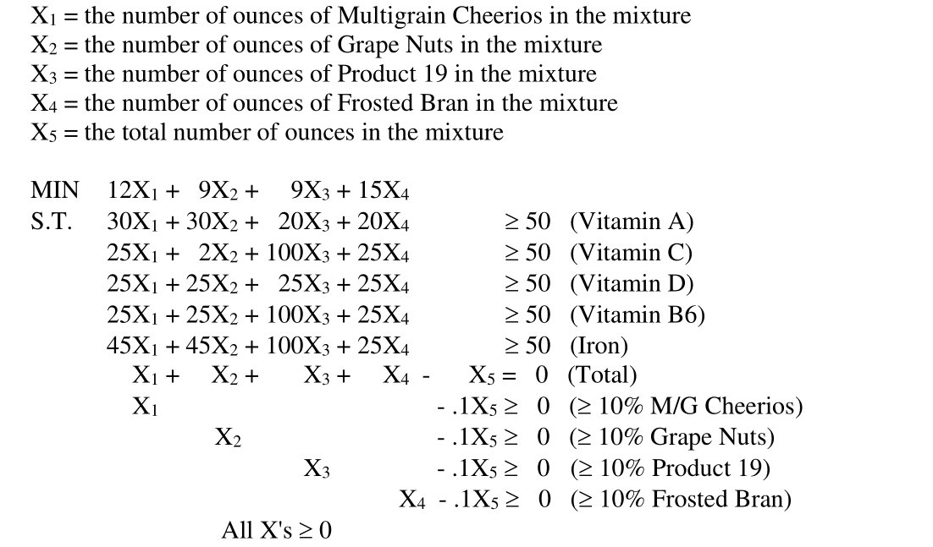

## **Solution:**

## **Interpretation of Results:**

# **Problem 11**

## **Solution:**

## **Interpretation of Results:**

# **Problem 12**

## **Solution:**

## **Interpretation of Results:**

# **Problem 13**

## **Solution:**

## **Interpretation of Results:**

# **Problem 14**

## **Solution:**

## **Interpretation of Results:**

# **Problem 15**

## **Solution:**

## **Interpretation of Results:**